Week 2

1. In which layer of the TCP/IP five-layer model of the internet does the http protocol function?

1. Link layer
2. Transport layer
3. **Application layer**
4. Physical layer
5. Network layer

2. What is the correct syntax for a comment in HTML?

1. # Comment
2. /*Comment*/
3. **<!-- Comment -->**
4. // Comment

3. True or False: Whitespace is preserved in a paragraph <p> tag.

1. True
2. **False**

4. What is the correct way of writing an ampersand & in HTML?

1. **&amp;**
2. #amp;
3. &and;
4. 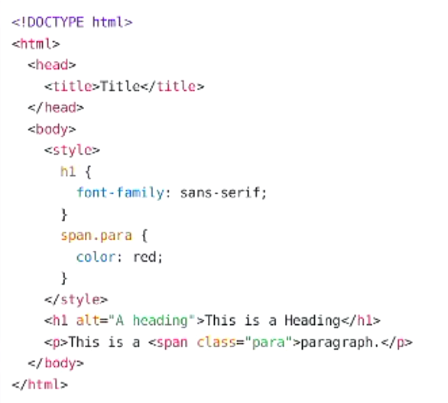#and
5. **&#38;**
6. &

5. The following HTML page does not pass validation. Why?

1. background-color not allowed to style a span
2. **<span> missing closing tag**
3. Doctype declaration incorrect
4. <p> tag ended early
5. **<style> tag not allowed in <body>**
6. **alt attribute in h1 tag**

Week 3

1. What is the correct HTML for adding an external style sheet to web page?

1. <p style="mystyle.css"></p>
2. **<link rel="stylesheet" type="text/css" href="mystyle.css">**
3. <style src="mystyle.css">
4. <stylesheet>mystyle.css</stylesheet>

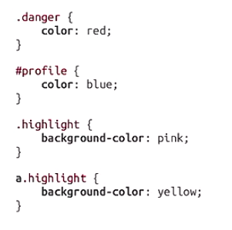2. Given the above stylesheet, which of the given elements is highlighted yellow?

1. <a id="highlight">TEXT</a>
2. <p class="highlight">TEXT</p>
3. **<a class="highlight">TEXT</a>**
4. <p id="highlight">TEXT</p>

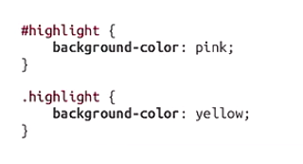3. Given the above stylesheet, which of the given elements is highlighted pink?

1. <p class="highlight">TEXT</p>
2. <p class="color:pink;">TEXT</p>
3. <p>highlight</p>
4. **<p id="highlight">TEXT</p>**

4. Which of the given options is not a part of the CSS box model?

1. Border
2. **Outer**
3. Margin
4. Content

5. Which of the given options will be appear like the red box as shown above?

1. <span style=" background-color:red; width:200px; height:200px;"></div>
2. **<span style="display:block; background-color:red; width:200px;height:200px;"></span>**
3. <div style="display:none; background-color:red; width:200px;height:200px;"></div>
4. <div style="display:inline; background-color:red; width:200px;height:200px;"></div>

Week 4

1. Which of the given are advantages of client-side dynamic programming?

1. **Allow web pages to change without reloading**
2. **Reduces server load**
3. All of these!
4. **Can reduce network load**
5. Allows running of code that is too complex for the server.

2. Which of the given is correct Javascript for a FOR loop that iterates over an array and prints the result to the debugging console?



int[] array = {1,2,3};  
for (int i=0; i<array.length; i++) {  
 console.log(i);  
}

**Correct!**



var array = [1,2,3];  
for (var i=0; i<array.length; i++) {  
 console.log(i);  
}



int[] array = [1,2,3];  
for (int i=0; i<size(array); i++) {  
 print(i);  
}



var array = {1,2,3};  
for (var i=0; i<size(array); i++) {  
 print(i);  
}

3. Consider this HTML:

<p id="pl" class="a">Paragraph 1</p>

<p id="p2" class="a b">Paragraph 2</p>

<p id="p3" class="b">Paragraph 3</p>

Which of the given Javascript statements will select ONLY the paragraph Paragraph 2?

1. **document.querySelector("p.a.b");**
2. **document.getElementById("p2");**
3. document.getElementsByClassName("a b");
4. document.getElementsByClassName("a");
5. document.getElementsByTagName("p");

4. Which of the given Javascript conditionals will evaluate to true?

1. ("0" === false)
2. (0 == "false")
3. **(1 == true)**
4. **("0" == false)**

5. Which of the following is correct Javascript to create a <div> element and add it as the last element in the body?



var element = document.createElement("DIV");  
document.body.add(element);

**Correct!**



var element = document.createElement("DIV");  
document.body.appendChild(element);



var element = document.newElement("DIV");  
document.body.appendChild(element);



var element = document.newElement("DIV");  
document.body.add(element);

Week 5

1. Which of the following is the protocol used for sending and receiving webpage requests on the Internet?

1. FTP
2. HTML
3. **HTTP**
4. GET

2. Which of the following series of HTTP response codes notifies the client than an error has occurred?

1. 3XX Series
2. **4XX Series**
3. 1XX Series
4. 2XX Series
5. **5XX Series**

3. A GET request contains a body. True or False?

1. **False**
2. True

4. What is the default port for an Express server set up with the Express Generator?

1. 8080
2. 8000
3. 3030
4. **3000**
5. 80
6. 443

5. What is the command to run an Express server set up with the Express Generator?

1. node index.js
2. express run
3. npm run
4. **npm start**
5. node start

Week 6

1. Which of the following statement is true for attributes in ER model?

1. **Relationship sets can have an attribute**
2. When the data that will be stored a attribute can be broken into several logical pieces, we should make composite attributes for that attribute
3. For the derived attributes, the value can be derived from anywhere (no need to be based on the value of another attribute in a entity set)
4. **Entity attributes can be either single, composite, multi-value, and derived**

2. Matching the following requirements with the appropriate cardinalities.

1. Store student's address in home country in a separate table – **One to one relationship**
2. Each customer can hires one or more phone lines – **One to many relationship**
3. Books must be kept in a certain shelf – **Many to one relationship**
4. Record enrolled courses of students – **Many to many relationship**

3. Matching ER model and its diagram

1. Weak entity – **Double rectangles**
2. Partial participation – **Single lines link between a relationship sets and an entity set**
3. Composite attributes – **Ellipse**
4. Many to many relationships – **Undirected lines**

4. Consider the following database tables from lectures

Customer

|  |  |  |  |
| --- | --- | --- | --- |
| CustID | Given | FamilyName | PhoneNumber |
| 1 | Alice | Smith | 0412 345 678 |
| 2 | Bob | James | 0498 765 432 |
| 3 | Carol | Parker | 0411 222 333 |

Purchase_Contents

|  |  |
| --- | --- |
| PurchaseID | ItemID |
| 1 | 1 |
| 2 | 2 |
| 2 | 1 |
| 2 | 3 |
| 3 | 4 |
| 4 | 1 |

Item

|  |  |  |  |
| --- | --- | --- | --- |
| ItemID | ItemName | Price | Barcode |
| 1 | Cling Wrap | 1.19 | 12345 78654 |
| 2 | Detergent | 12.34 | 48325 65404 |
| 3 | Blanket | 39.99 | 64597 15632 |
| 4 | Mushrooms | 9.99 | 85146 15647 |

Purchase

|  |  |  |
| --- | --- | --- |
| PurchaseID | CustID | PurchaseDate |
| 1 | 1 | 2019-03-30 |
| 2 | 2 | 2019-04-01 |
| 3 | 2 | 2019-04-02 |
| 4 | 3 | 2019-04-02 |

4. Which of the following SQL queries will change the price of Mushrooms to 8.99?



UPDATE INTO Item (ItemName)  
VALUES (Price = 8.99);



UPDATE Mushrooms  
SET Price = 8.99  
WHERE TABLE = Item;



UPDATE INTO Item  
SET Mushrooms.Price = 8.99;



UPDATE Item  
SET Price = 8.99  
WHERE ItemName = 'Mushrooms';

5. Which of the following SQL queries will list only the Full Names of all Customers who made Purchases on 2019-04-02?



SELECT GivenName,FamilyName  
FROM Customer INNER JOIN Purchase  
 on Customer.CustID = Purchase.CustIDWHERE PurchaseDate = '2019-04-02';



SELECT GivenName,FamilyName  
FROM Customer INNER JOIN Purchase  
 on Customer.CustID = Purchase.CustID  
WHERE PurchaseDate = '2019-04-02';



SELECT * FROM Customer AND Purchase  
WHERE PurchaseDate LIKE '2019-04-02';



SELECT *  
FROM Customer INNER JOIN Purchase  
 on Customer.CustID = Purchase.CustID;

Week 8

1. What is the correct syntax for inserting a Vue.js data property data into a paragraph tag as text?

1. <p>Vue.data</p>
2. <p>[[ Vue.data ]]</p>
3. <p>{ Vue.data }</p>
4. **<p>{{ data }}</p>**
5. <p>[ data ]</p>

2. What is the correct syntax for inserting a Vue.js data property data into a paragraph tag’s id attribute?

1. <p v-bind:data="{{id}}"></p>
2. <p v-id="data"></p>
3. **<p v-bind:id="data"></p>**
4. <p id="{{data}}"></p>

3. What is the resulting HTML from this Vue.js template?

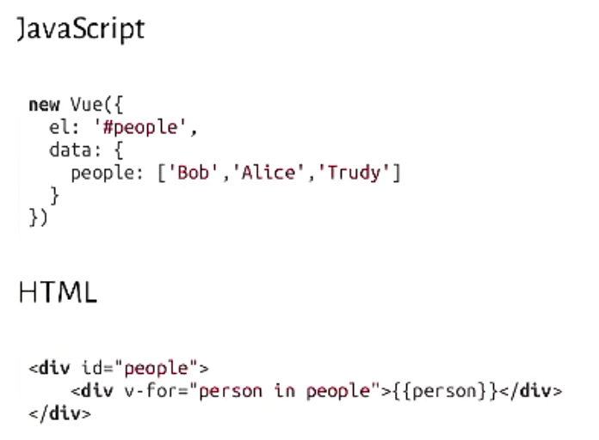



<div id="people">

<div>Trudy</div>

</div>

**Correct!**



<div id="people">

<div>Bob</div>

<div>Alice</div>

<div>Trudy</div>

</div>



<div id="people">

<div>Bob</div>

</div>

<div id="people">

<div>Alice</div>

</div>

<div id="people">

<div>Trudy</div>

</div>



<div id="people">

<div>Bob</div>

</div>

4. Whar does v-model = “item” in this code do?

1. <input v-model=”val” value=”my val”>
2. **Whenever the value of the Vue data property changes, the text input will update**
3. Replaces the 'val' in the value attribute with the Vue data property's value
4. Binds the model attribute of the text box to Vue.js
5. **Whenever the value of the text input changes, the Vue data property will update**

5. Which of the following statement about Vue.js components are true?

1. **Components can replace tags of the same name in the page**
2. **Components can have their own, independent sets of data**
3. **Components have their own templates**
4. **Components are reusable**
5. **Components can be updated with data from the main Vue instance**

Week 9

1. True or false?

If there is no data to send in response to an AJAX request, you don't need to send a response.

1. True
2. **False**

2. Consider the following Javascript Object to be sent via an AJAX POST request:

**var** john = {name: "John", age: 56};

Which of the following AJAX calls is correct way to send this JSON in a POST request to the server?



**var** xhttp = **new** XMLHttpRequest();

xhttp.setRequestHeader("Content-type", "text/json");

xhttp.open("POST", "person.json", true);

xhttp.send(john);



**var** xhttp = **new** XMLHttpRequest();

xhttp.open("POST", "person.json", JSON.stringify(john), true);

xhttp.setRequestHeader("Content-type", "application/json");

xhttp.send();

**Correct!**



**var** xhttp = **new** XMLHttpRequest();

xhttp.open("POST", "person.json", true);

xhttp.setRequestHeader("Content-type", "application/json");

xhttp.send(JSON.stringify(john));



**var** xhttp = **new** XMLHttpRequest();

xhttp.open("POST", "person.json", true);

xhttp.send(JSON.stringify(john));

3. Which of the following Node.JS express router methods is the correct way to access the value of the 'name' key for the object in question 2.



router.post('/person.json', **function**(req, res) {

**var** name = JSON.**parse**(req.body).name;

// Do stuff

res.send('');

});



router.post('/person.json', **function**(req, res) {

**var** name = res.body.name;

// Do stuff

res.send('');

});



router.post('/person.json', **function**(req, res) {

**var** name = req.body.name;

// Do stuff

res.send('');

});



router.get('/person.json', **function**(req, res) {

**var** name = JSON.**parse**(res.body).name;

// Do stuff

res.send('');

});

4. Which of the following statements about Cookies are true?

1. **Cookies are useful for storing information short-term.**
2. Cookies allow the client to store state information on the server
3. Cookies are a safe way to store sensitive site information.
4. Cookies are useful for storing information long-term.
5. **Cookies allow the server to store state information on the client**

5. Which of the following statements about Sessions are true?

1. **Sessions are stored using a special type of Cookie.**
2. **Session middleware needs to be installed in express to easily access session details.**
3. **The session ID can be accessed in our router methods using req.session.id**
4. The session ID can be accessed in our router methods using res.session.val
5. **Sessions can be used to prevent a client from needing to log in to each page they visit.**
6. Sessions are established automatically as part of the default express configuration.

Week 10

1. What is the role of the next( ); parameter/call in this express code?

router .use(function (req, res, next) {

console . log ( ' Time: ' +Date . now( ));

next( );

});

1. **Passes the request to the next piece of middleware.**
2. Sends the request to the next server.
3. Increments the Date.
4. Terminates the request to process the next response.

2. True or False? Routes are a type of middleware.

1. **True**
2. False

3. True or False?

When a user logs in with OpenID, the Identity provider sends a token to the express server.

1. True
2. **False**

4. What is the role of this app.use express code when using a MySQL database with your Web Application?

var dbConnectionPool = mysql.createPool({ host: 'localhost', database: 'db'});

app. use(function( req, res, next) {

req. pool = dbConnectionPool;

next();

});

1. Runs a query on the database
2. **Makes the database available in routes as req.pool**
3. Resets the database for each new request

5. What does the ? (Question Mark) in this code do?

connection.query("SELECT * FROM Users WHERE username = ?",

[username], function(err, rows, fields) {

connection. release();   
res.json(rows);

} ) ;

1. **Acts as a placeholder for the variable username**
2. Acts as a placeholder for the array containing username
3. Is a literal question mark character
4. Is automatically replaced with user input

Week 12

1. Match the following MySQL functions with what they do:

1. COUNT() – **Returns the number items in a group**
2. LOWER() – **Converts a string to lowercase**
3. ROUND() – **Rounds a number mathematically**

2. Which of the following statements about SQL views are true?

1. **A view can be queried like a table.**
2. **A view can be used to simulate derived attributes.**
3. A view can be run like a query.
4. A CREATE VIEW statement has to end with GO;

3. What is the correct MySQL keyword used to return only the first row from a SELECT query?

1. **LIMIT 1**
2. BEST
3. TOP 1
4. FIRST

4. Logically, what is the first part of a SQL statement to be evaluated?

1. **FROM**
2. WHERE
3. SELECT
4. DISTINCT

5. Which of the following is a way that performance of our databases can be improved?

1. Minimising multi-table joins
2. Prefiltering results using Common Table Expressiosn
3. **All of these!**
4. Using queries that can work with sorted data
5. Indexing frequently accessed columns

Week 13

1. The best way to store passwords is:

1. **Hash + Salt**
2. Hash only
3. Encrypted
4. Plain text

2. Which of the following methods is the best way to protect against SQL injection attacks?

1. Use the connection.escape method on strings that are getting added to a query.
2. Restrict database user privledges.
3. Use string concatenation
4. Apply field validation on the cient
5. **Use prepared statements (? substitution)**

3. Which of the following best describes a Cross-Site Scripting (XSS) attack?

1. Sending a script from one site to another.
2. **Inserting a script into a page's content so that it will be run by other users of a site.**
3. A script that causes a user on one site to connect to another site.

4. Which of the following best describes a Cross-Site Request Forgery (XSRF) attack?

1. Intercepting and modifying a request as it travels between different sites.
2. **Using a user's session for one site to send a request to that site from another site.**
3. Creating a fake request that appears to be from one site but is from another.

5. Match the following elements of security with their descriptions:

1. Authentication – **Identifying a user.**
2. Authorisation – **Limiting a user’s actions.**
3. Availability – **Ensuring the system is able to be used.**
4. Integrity – **Limiting how information is modified.**
5. Auditing – **identifying actions taken by user.**
6. Confidentially – **Limiting access to information.**